Government considering ‘opt-out’ change to organ donation system

**A drastic change being considered by the Australian government would see residents automatically listed as organ donors as part of a new opt-out system.**

[https://s.wp.com/wp-content/themes/vip/newscorpau-nca/assets/dist/img/common/headshots/mini/alexandra-foster.png](https://www.news.com.au/the-team/ally-foster)

[**Ally Foster**](https://www.news.com.au/the-team/ally-foster)[**@allyjfoster**](http://twitter.com/allyjfoster)

https://i1.wp.com/pixel.tcog.cp1.news.com.au/track/component/author/b0bef69e2cdb8a0eacce5e460385b9ba?t_product=tcog&t_template=s3/ncatemp/authorBlock@2.0.0

Featured on News.com.au DECEMBER 10, 2018 **3:28PM**

https://i1.wp.com/pixel.tcog.cp1.news.com.au/track/news/content/v2/16d8edd2ee82fe0d1a457d6cacabd332?t_product=newscomau&t_template=../video/player

Australians may soon be automatically registered as organ donors as part of a proposed change to combat the rise of people buying organs on the black market.

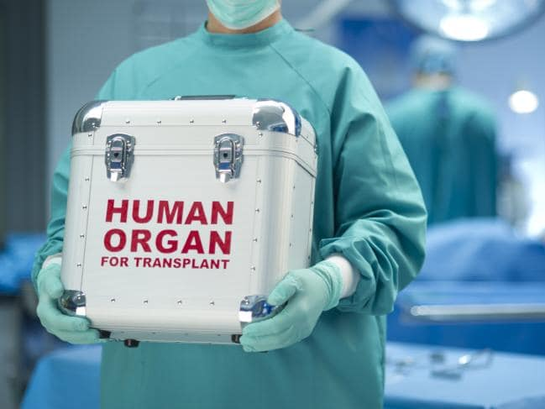The Government is reportedly considering taking an “opt-out” approach to organ donation which would see citizens have to specifically state that they don’t want to be a donor.

The [Human Organ Trafficking and Organ Transplant Tourism](https://www.aph.gov.au/Parliamentary_Business/Committees/Joint/Foreign_Affairs_Defence_and_Trade/HumanOrganTrafficking/Tabled_Reports)report, tabled in parliament last week, found the current national demand for donors far outstrips the available supply of organs.

This is resulting in an increasing number of people turning to the black market for organ transplants.

More than 1400 Australians are waiting for organ transplants.*Source:Supplied*

As of September 2018 there were 1423 people on organ transplant lists in Australia, with 1003 of those awaiting kidney transplants.

Due to the high demand for organs, many don’t survive the waiting period.

On the black market, kidneys can be purchased for anywhere between $68,000 and $163,000.

“Desperate people, often facing end-stage renal disease and other grave conditions, may travel to distant countries and pay tens of thousands of dollars and more, for an organ transplant where the donor is poor, exploited or unable to give free and informed consent to donation,” the report read.

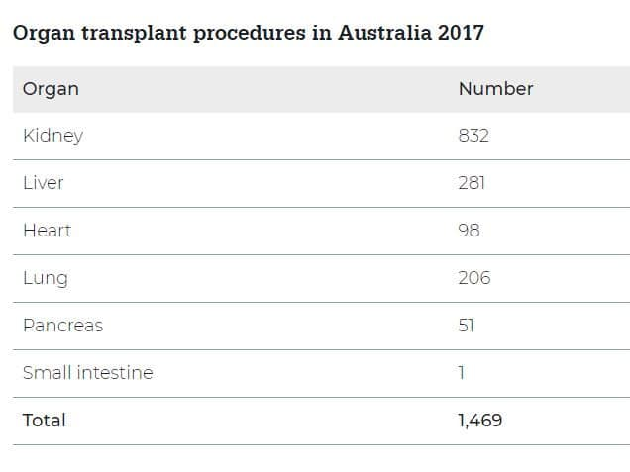

Kidneys are the most common organs needed. Picture: Donate Life*Source:Supplied*

Along with the proposal to switch to an opt-out system, some federal MPs have also suggested the law be changed so Australians who go overseas to have an illegal organ transplant can be charged on their return.

They also suggested that those in the medical community should be forced by law to report any knowledge or reasonable suspicion that someone under their care has received a commercial transplant.

According to the human rights sub-committee of the Joint Standing Committee on Foreign Affairs, which authored the report, black market organ trafficking will only continue to grow if nothing is done.

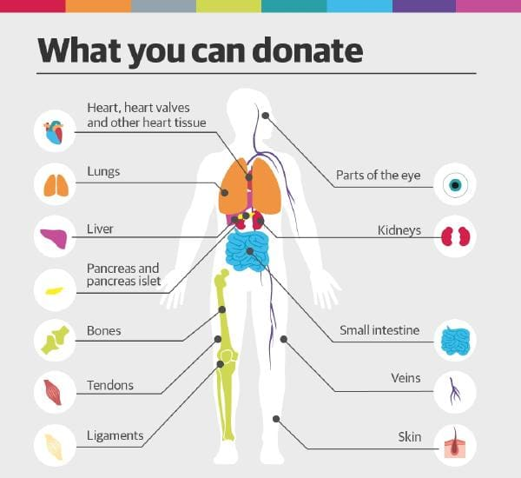

What organs you can donate.*Source:Supplied*

Under Australia’s current organ donation program, only one in three people are registered as donors.

This is despite the majority of Australians saying they are willing to donate their organs if they die.

Of the 10 top donating countries in the world, seven of them have had an opt-out system in place for a number of years, with two others adopting the policy in the past year.

However, even if organ donation rates are increased, the report’s authors believe organ supply won’t be able to meet the total demand anytime in the foreseeable future — meaning Australia needs measures to address organ trafficking sooner rather than later.